Pupil premium strategy statement

Before completing this template, you should read the guidance on using pupil premium.

Before publishing your completed statement, you should delete the instructions (text in italics) in this template, including this text box.

This statement details our school’s use of pupil premium (and recovery premium for the 2021 to 2022 academic year) funding to help improve the attainment of our disadvantaged pupils.

It outlines our pupil premium strategy, how we intend to spend the funding in this academic year and the effect that last year’s spending of pupil premium had within our school.

School overview
Detail | Data
School name | Gillingham Primary
Number of pupils in school | 55
Proportion (%) of pupil premium eligible pupils | 30%
Academic year/years that our current pupil premium strategy plan covers (3 year plans are recommended) | 2021-2024
Date this statement was published | October 2022
Date on which it will be reviewed | September 2023
Statement authorised by | Heather Brand
Pupil premium lead | Maria Adcock
Governor / Trustee lead | Alan Larkin
Funding overview
Detail | Amount
Pupil premium funding allocation this academic year | £20,775
Recovery premium funding allocation this academic year | £0
Pupil premium funding carried forward from previous years (enter £0 if not applicable) | £0
Total budget for this academic year  If your school is an academy in a trust that pools this funding, state the amount available to your school this academic year | £20,775

Part A: Pupil premium strategy plan

Statement of intent
At Gillingham Primary School we want all children to have the best educational opportunities and to achieve to the best of their potential. We want all children to make expected progress in reading, writing and maths. We believe in offering the same opportunities to all children and this includes our extra-curricular activities and visits that enhance the learning experience.
Our ultimate objectives for disadvantaged pupils are:
- To make expected progress in reading, writing and maths
- To narrow the attainment gap
- To fully embrace the whole curriculum offer, with funding support for extra-curricular activities
We aim to meet these objectives in the following ways:
- Ensure children have quality first teaching that is scaffolded to support children where necessary
- Ensure appropriate scaffolding and interventions are in place to support children’s learning and help to close the gaps in their knowledge.
- Thorough question level analysis of assessments to ensure we are targeting the correct gaps.
- Supporting families with payments to extra-curricular clubs and enrichment where needed

Challenges

This details the key challenges to achievement that we have identified among our disadvantaged pupils.
Challenge number | Detail of challenge
1 | Poor engagement with reading for pleasure, especially at home
2 | The gap between PP children and Non PP children in writing particularly is wider than other subjects, also a focus on maths
3 | Some of our pupil premium children do not have the varied experiences as non-pupil premium children seem to have meaning knowledge of the world and vocabulary is limited
4 | Children do not always remember the content of what they have been learning and apply it to other areas of learning.
5

Intended outcomes
This explains the outcomes we are aiming for by the end of our current strategy plan, and how we will measure whether they have been achieved.
Intended outcome | Success criteria
To improve engagement with reading for pleasure. | Children will engage with Kingfisher Reading Wings – our weekly class reward for reading at home.  Parents will be more aware of the importance of reading at home and sharing books together.
For PP children to make expected progress in writing and achieve expected levels with a focus also on spelling | Children will reach expected levels within writing and make expected progress
For PP children to have access to extra-curricular activities and visits to enhance learning | PP children will take up opportunities with extra-curricular activities and attend visits and residential.
For children to remember key facts about what they learnt and to apply their knowledge in other areas of learning | Introduction of ‘sticky’ quizzes will demonstrate what children remember from their learning.

Activity in this academic year
This details how we intend to spend our pupil premium (and recovery premium funding) this academic year to address the challenges listed above.

Teaching (for example, CPD, recruitment and retention)
Budgeted cost: £ 3000
Activity | Evidence that supports this approach | Challenge number(s) addressed
PiXL to help identify learning gaps by using summative questions formatively. Enables reliable benchmarking using ready-made assessments. | EEF states that:  Small group tuition has an average impact of four months’ additional progress over the course of a year.  Small group tuition is most likely to be effective if it is targeted at pupils’ specific needs. Diagnostic assessment can be used to assess the best way to target support. | 1, 2, 3, 4
Read Write Inc. synthetic phonics programme | Education Endowment Foundation (EEF) Phonics. The average impact of the adoption of phonics approaches is about an additional five months’ progress over the course of a year. Phonics approaches have been consistently found to be effective in supporting younger pupils to master the basics of reading, with an average impact of an additional five months’ progress.  Studies in England have shown that pupils eligible for free school meals typically receive similar or slightly greater benefit from phonics interventions and approaches. This is likely to be due to the explicit nature of the instruction and the intensive support provided. | 1, 2
Clicker 8 training to ensure all teachers know the best ways to use it with the children in their class. | Clicker says it has improved engagement levels and helped our pupils develop a far more positive attitude to writing, the best thing about Clicker is that it boosts children’s confidence and allows them to see themselves as writers. It removes barriers to writing, and it takes away some of that cognitive demand and overload, so children can record their ideas and gain confidence | 2, 3, 4
NCETM TRG membership including CPD courses Curriculum Leader networks and Association | Extensive research has shown that improved quality of teaching is most effective in supporting all children, but will disproportionately benefit those with less support or access to educational resources at home.

Targeted academic support (for example, tutoring, one-to-one support structured interventions)
Budgeted cost: £13000
Activity | Evidence that supports this approach | Challenge number(s) addressed
Small group support Reading and maths additional intervention Investment in TA provision enables targeted support, for example, pre teaching and specific interventions to take place | EEF Small group tuition (+4 months progress, on average, over the course of a year) EEF Teaching Assistant interventions (+4 months progress on average, over the course of a year) | 1
The use of Clicker to support those children that find handwriting challenging and have a barrier to writing/spelling | Clicker says it has improved engagement levels and helped our pupils develop a far more positive attitude to writing, the best thing about Clicker is that it boosts children’s confidence and allows them to see themselves as writers. It removes barriers to writing, and it takes away some of that cognitive demand and overload, so children can record their ideas and gain confidence | 2, 4
Dyslexia Gold to support and improve spelling | Dyslexia Gold is an evidence-based programme to help pupils progress with spelling and reading | 2, 3, 4

Wider strategies (for example, related to attendance, behaviour, wellbeing)
Budgeted cost: £4775
Activity | Evidence that supports this approach | Challenge number(s) addressed
To support children to attend extra-curricular clubs and visits to enhance learning School pays 50% of a club and visit each half term. | EEF – sports participation increases educational engagement and attainment.  EEF – outdoor adventure learning shows positive benefits on academic learning and self -confidence. | 3
Contingency fund for any issues that may arise during the course of the year. | Based on previous experiences we have identified a need to set a small amount of funding aside to respond quickly to needs that have not yet been identified.

Total budgeted cost: £ 20775

Part B: Review of outcomes in the previous academic year

Pupil premium strategy outcomes
This details the impact that our pupil premium activity had on pupils in the 2021 to 2022 academic year.
Teaching:
The tables below compare our school to the national Pixl results
Reading
Year Group | National Pixl | School Pixl
1 | 55.28% | 77.50%
3 | 58.17% | 75.56%
4 | 57.41% | 66.88%
5 | 59.20% | 58.59%

SPAG
Year Group | Paper | National Pixl | School Pixl
3 | 1 | 59.89% | 58.10%
3 | 2 | 60.97% | 55.71%
4 | 1 | 55.82% | 62.31%
4 | 2 | 59.82% | 62.31%
5 | 1 | 55.27% | 52.63%
5 | 2 | 57.67% | 56.56%

Maths
Year Group | Paper | National Pixl | School Pixl
1 |  | 59.03% | 68.33%
3 | 1 | 55.91% | 55.91%
3 | 2 | 42.28% | 59.17%
4 | 1 | 68.33% | 66.88%
4 | 2 | 44.94% | 44.72%
4 | 3 | 43.42% | 50.28%
5 | 1 | 62.66% | 71.14%
5 | 2 | 45.88% | 68.31%
5 | 3 | 47.35% | 58.44%

End of Year 2/EYFS
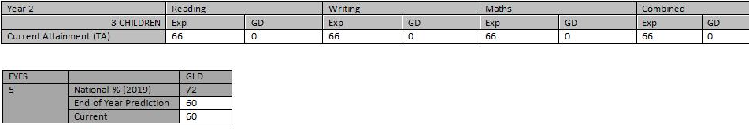

End of Year 6
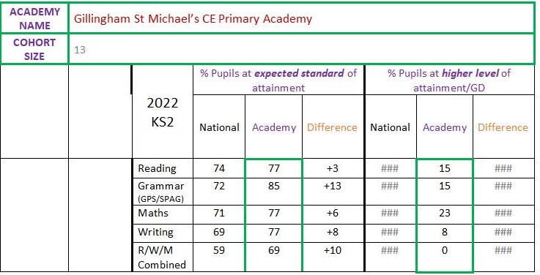
Disadvantaged attainment on its own
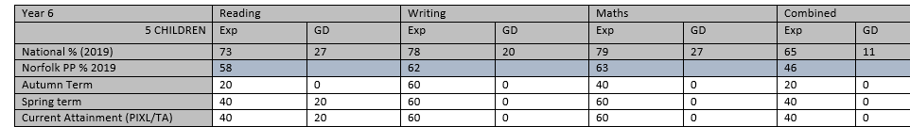
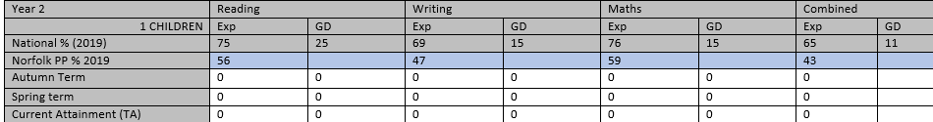
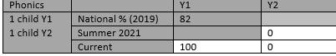
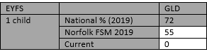

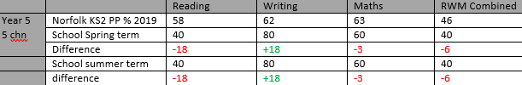
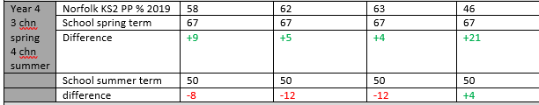
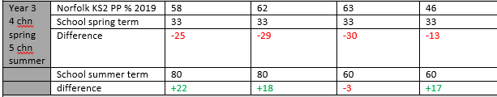
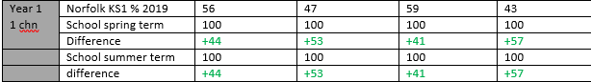
Teaching and learning
As these outcomes show, impact of specific intervention and staff training in spelling and grammar, led to results that were broadly in line with the national Pixl results. A difference from the year before where we were below. There are still some specific gaps identified from QLA and feedback from staff indicates focus needs to be placed on the teaching of spelling into next academic year.
Specialist training was sought from the Dyslexia Outreach service. The work completed with staff ensured that al pupils felt able to engage and interact fully with the wide curriculum offer. Monitoring showed clear evidence of specific scaffolding and provision of a range of resources.

Targeted Support
In reading within KS2 we are above the national percentage – this demonstrates that our targeted teaching and support is having an impact on the children.
Children made good progress across the curriculum, evidenced through use of low stakes quizzes at key points and use of other assessment tools. Pupils were able to speak confidently about the knowledge they had learnt and demonstrate this in the work that they produced.

Wider Strategies
A range of experiences were offered to all children, with excellent engagement in clubs offered at different points in the day. We plan to continue to look at the variety of this offer.
After not being able to run these for a few years due to covid, we were pleased that all children took part in our residential trips at KS2 due to the support given financially. The children were able to build their social skills by working with other children.
.

Externally provided programmes
Please include the names of any non-DfE programmes that you purchased in the previous academic year. This will help the Department for Education identify which ones are popular in England
Programme | Provider
Emilie – for maths support | Emilie education

Further information (optional)
Use this space to provide any further information about your pupil premium strategy. For example, about your strategy planning, or other activity that you are implementing to support disadvantaged pupils, that is not dependent on pupil premium or recovery premium funding.

